**Front-End UI/UX Mini Project**

**Project Submission Template**

**1. Title Page**

* **Project Title**: Event Registration Website
* **Submitted By**:

Naveen Tijo 2463039 naveentijo.btech.christuniversity.in

Chris Sunny Padayattil 2463016 chris.sunny@btech.christuniversity.in

Lana T 2463036 t.lana@btech.christuniversity.in

* **Course**: UI/UX Design Fundamentals
* **Instructor Name**: Dhiraj Alate
* **Institution**: Christ University
* **Date of Submission**: 13/8/2025

**2. Abstract**

This project is a two-page event registration website designed using HTML5 and CSS3. It allows users to register for an event by filling out their personal and event details. Upon submission, the user is redirected to a confirmation page. The project emphasizes clean form design, semantic HTML structure, and responsive styling using CSS Flexbox. The final outcome is a user-friendly static website that can be used for offline demonstrations or hosted online for real event sign-ups (with backend integration in the future).

**3. Objectives**

•Design an intuitive registration form for an event.

•Use semantic HTML for proper content structure.

• Apply CSS styling for improved visual appeal and usability.

•Ensure responsiveness for desktop, tablet, and mobile screens.

•Create a confirmation page for user acknowledgment after form submission.

**4. Scope of the Project**

• Front-end only: No backend or JavaScript functionality.

•Consists of two pages:

1. **Registration Page** – Form for user details.
2. **Confirmation Page** – Thank-you message after submission.

•Offline-capable and suitable for basic demonstrations.

**5. Tools & Technologies Used**

|  |  |
| --- | --- |
| Tool/Technology | Purpose |
| HTML5 | Markup and content structure |
| CSS3 | Styling and layout management |
| VS Code | Code editor |
| Chrome DevTools | Testing and debugging |

**6. HTML Structure Overview**

* Semantic tags: <header>, <main>, <section>, <form>, <footer>.
* Form fields:
  + Text inputs for Name, Email, and Phone.
  + Dropdown menu for event selection.
  + Date picker for preferred date.
  + Submit button for registration.
* Confirmation page includes a short thank-you message and an option to register another participant.

**7. CSS Styling Strategy**

•External stylesheet (style.css) for both pages.

•Flexbox for centering the form content.

•Consistent padding, margins, and font sizes for readability.

•Color scheme matching event branding (primary color for headers/buttons,

light backgrounds for form sections).

• Media queries for mobile-friendly layout.

**8. Key Features**

|  |  |
| --- | --- |
| Feature | Description |
| Responsive Design | Adapts seamlessly to all screen sizes |
| Smooth Navigation | Fixed top nav with anchor links |
| Project Cards | Flex-based layout with hover effects |
| Contact Form (non-functional) | Placeholder layout for inputs and button |
| Accessible Fonts & Colors | High contrast and readable typography |

**9. Challenges Faced & Solutions**

|  |  |
| --- | --- |
| Challenge | Solution |
| Overlapping elements on small screens | Used media queries to stack elements |
| Difficulty aligning items using float | Shifted to Flexbox and Grid |
| Typography scaling issue | Used relative units (em/rem) instead of px |

**10. Outcome**

• Delivered a functional and responsive event registration page without using JavaScript.

•Enhanced understanding of HTML form elements and their accessibility attributes.

•Gained practical experience in styling forms and building a confirmation workflow with static pages.

•Developed the ability to organize multi-page website structures effectively.

**11. Future Enhancements**

•Add JavaScript for client-side form validation.

•Connect to a backend to store submitted form data.

•Send automated confirmation emails to registered users.

•Add multiple event selection and payment gateway integration.

**12. Sample Code**

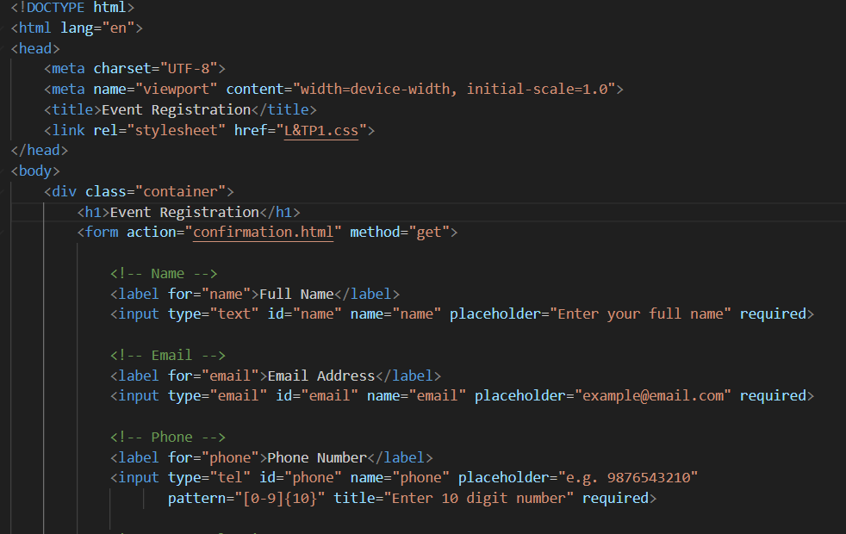

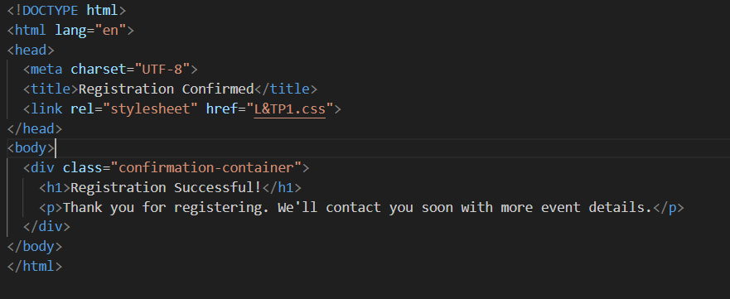

**13. Screenshots of Final Output**

**From Laptop**

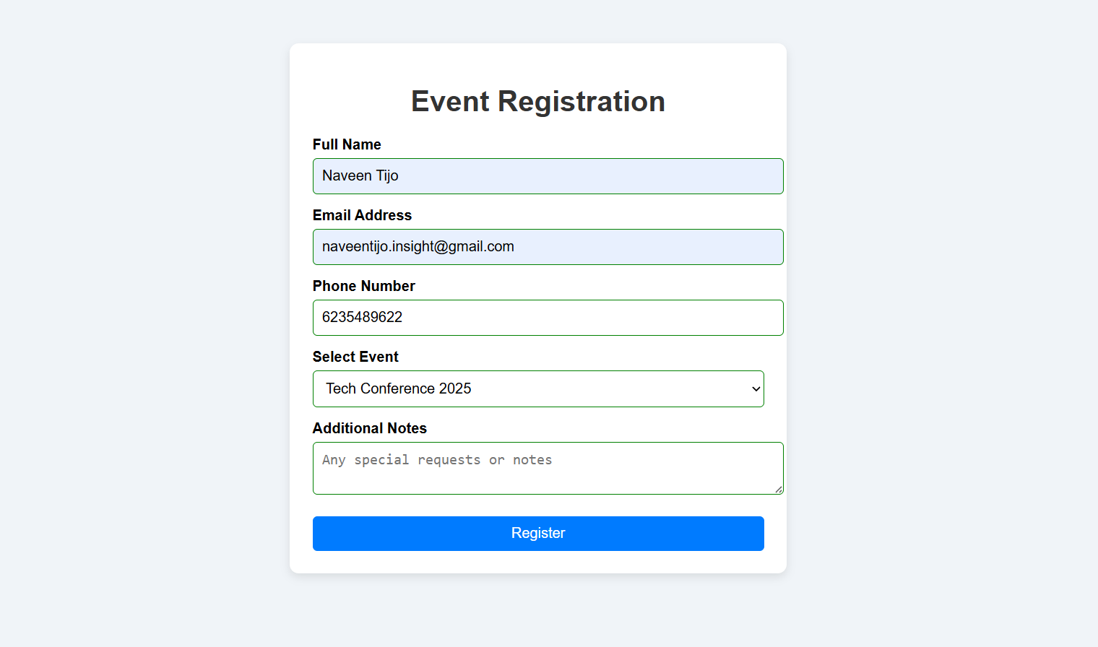

**From Phone**

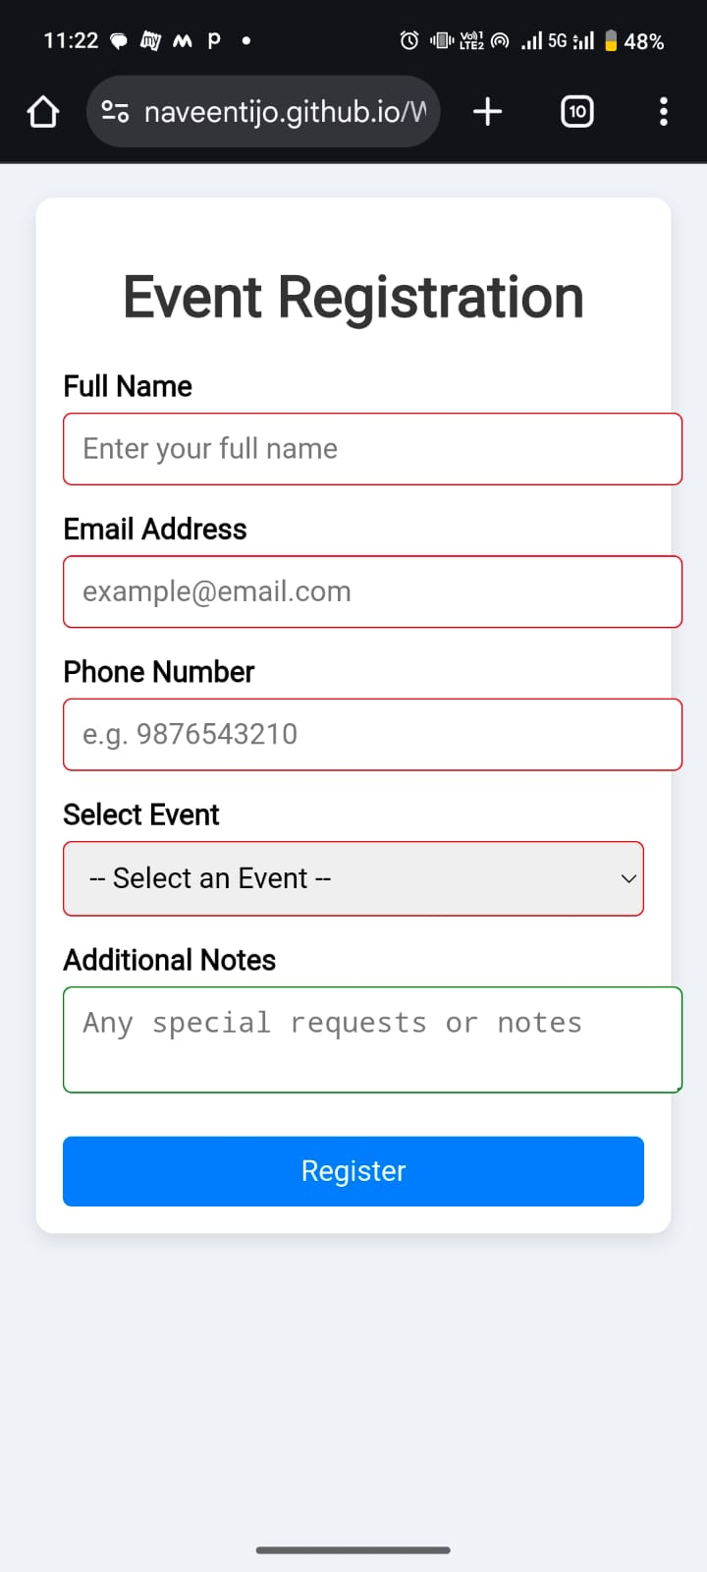

**11. Conclusion**

The Event Registration Website demonstrates the application of HTML5 and CSS3 in creating a functional and visually appealing web form. The process improved understanding of semantic HTML, form accessibility, and responsive design. Although this is a front-end-only project, it lays the groundwork for more complex event management systems in the future.

**12. References**

•L&T LMS – <https://learn.lntedutech.com>

•W3Schools HTML & CSS Documentation – https://www.w3schools.com